Contact:
Please direct all correspondence to the contact information provided below.

Hannah Colby, RD, LD, CLS
Registered Dietitian
Health Educator
Aitkin County Public Health
((218) 927-7271
hannah.colby@co.aitkin.mn.us

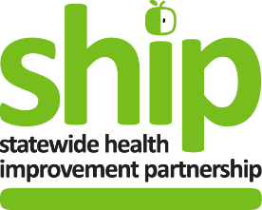

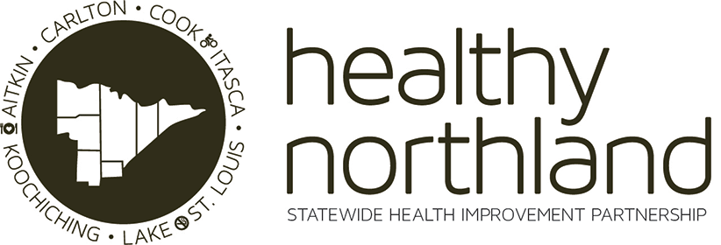

*Supported by the Statewide Health Improvement Partnership, Minnesota Department of Health

2023
Community Partner Funding Application

Section 1: Applicant Information
Date
Organization Name
Street Address
Mailing Address if different
City, State, Zip Code
County
Primary Contact
Phone
Email
Financial Contact
Phone
Email
Information provided in this application may be used for promotional materials. This includes, but is not limited to: fact sheets, Minnesota Department of Health reports, newsletters, social media posts, and media releases. Additional information may be requested by Sherburne County staff; e.g. a release might be requested for individuals in photographs.
☐ By checking this box, you acknowledge and accept the statement above.

Which project area are you applying under? Select only one.
(Your organization may apply for both a MN Well-being grant and one of the following: MN Eats, MN Moves or MN Commercial Tobacco Free grant. If choosing to do so, you must submit a separate application for each project.)
☐ MN Eats
☐ MN Moves
☐ MN Commercial Tobacco Free (CTF)
☐ MN Well-Being

Section 2: Project Description
PROJECT TYPE: Please select which project type BEST fits your proposal.
MN EATS
☐ SuperShelf
☐ FoodRx
☐ Breastfeeding (e.g., supportive spaces and places)
☐ Community Based Agriculture (Gardens)
☐ Workplace Gardens
☐ PSE work supporting healthy food in vending, cafeterias, and snack stations
☐ Healthy beverage access (e.g., water stations, vending, cafeterias)
☐ Community Food Assessments and Planning
☐ CACFP Guidelines
☐ Food and Nutrition Security
☐ Farm to School, Early Childhood, and/or Institution
☐ Farmers Markets
☐ Food Guidelines
☐ Healthy Food Retail such as Good Food Sold Here
☐ Baby Café
☐ Supporting students with chronic conditions (for example: oral health, food allergies, disordered eating, pre/diabetes)
☐ Comprehensive framework for addressing school nutrition environment and services (e.g., school meals, time for lunch, smart snacks, water access, healthy eating learning opportunities, staff role modeling, food and beverage marketing, celebrations and rewards, school nutrition and the social and emotional climate and learning)
MN MOVES
☐ Improve safety and access for active transportation and mobility
☐ Incorporate movement throughout children’s day
☐ Workplaces support active transportation throughout the day
☐ Workplaces support regular movement throughout the day
☐ Save routes to schools
☐ Park planning
☐ Destination design and placemaking policies
☐ Transit planning and access support
☐ Safe routes to food
☐ Support vision zero policies
☐ Local planning (includes zoning, land use, and comprehensive planning)
☐ Bicycle-friendly or walk-friendly certification (e.g., businesses, cities, campuses)
☐ Bicycle sharing program
☐ Cultural liaisons in parks
☐ Healthcare prescriptions such as Exercise is medicine such as Exercise Rx, Park Rx, Physical Activity as a Vital Sign
☐ Comprehensive school physical activity program (such as physical education, physical activity before and after school, physical activity during the day, family and community engagement, staff involvement)
☐ Outdoor school classrooms

MN COMMERCIAL TOBACCO FREE (CTF) or MN BREATHES
☐ Point of Sale
☐ Smoke-Free Housing
☐ Outdoor community and cultural spaces and events
☐ Behavioral health settings: Tobacco-free grounds and tobacco treatment integration
☐ Health care settings: Quit Partner referral integration.
☐ Public Health settings: Quit Partner referrals (such as, but not to limited to WIC, FHV, mental health services)
☐ Commercial tobacco-free schools (such as youth engagement, alternatives to suspensions, cessation promotion, grounds)
☐ Commercial tobacco free workplaces (grounds and cessation promotion)

MN WELL-BEING
☐ Incorporate social connection within SHIP activities through reframing policies and systems to ensure belonging
☐ Social and Emotional Learning projects
☐ Promoting community resilience and healing
☐ Addressing trauma
☐ Build trauma-informed principles into institutions (e.g., government agencies, community leaders, elected officials)
☐ Increasing cultural connection(s)
☐ Build trauma-informed principles into workplaces
☐ Healing benefits of nature
☐ Community-Clinical linkages for ACEs
☐ Health Literacy Interventions
☐ Support Telehealth and Telemedicine
☐ Healthy Brain Initiative
☐ Lifestyle Change Programs

PROJECT NAME: | <Replace text with your project name>

PROJECT NARRATIVE: Provide a brief description of your project, including
- history if any,
- intended initiative(s),
- Population served (include if any of the following priority populations will benefit: People age 60+, People age 18 and under, People with low-income backgrounds, People of color, American Indians, People with disabilities, People with mental illness)
  - How many total individuals do you expect to reach with this project?
  - Is there a disparity you are addressing with the population to be served?
- what other partners (if any) are involved and
- what impact you envision.
Include how the project will lead to changes to in at least one of these areas.
- policies (procedures, guidelines or regulations),
- systems (structures, procedures, or behaviors), or
- environments (atmosphere, surroundings, or settings).
<Replace this text with your narrative.>

PROJECT WORK PLAN: List your goals related to the project. Include planned activities to meet these goals, intended timeline and responsible individual(s). Add rows as needed.
GOAL: What is the goal(s) of the project?
<Replace this text with your goal(s).>
ACTIVITIES TO ACCOMPLISH GOAL(S) | TIMELINE | RESPONSIBLE INDIVIDUAL(S)

EVALUATION PLAN: What would indicate to you that this project was successful? How will you measure progress or change? Describe your anticipated impact(s). Add rows as needed.
Project Outcomes | How will you measure these changes? | What will you do with these results?

PROJECT SUSTAINABILITY: Identify how you will work to sustain the project beyond the initial grant funding. What is the plan for ensuring the policy, system or environment change (PSE) continues after funding ends? Please reference to “what is policy, system, environmental change” video on SHIP Website.
<Replace this text with your narrative.>

PROJECT COMMUNICATIONS: All communications pieces (not including Social Media posts) require prior approval before expenses are incurred; this includes all signage. If awarded, email communication pieces to Sherburne County staff for pre-approval.
☐ By checking this box, you acknowledge and accept the statement above.

Section 3: Budget and Funding Request
Please complete the total project funding table below and a detailed budget using the Community Partner Award Budget Proposal excel template provided.

Total Project Funding Table
- How much funding are you requesting from Sherburne County? | $
- How much other funding (if any) do you have for this project? Include other grants, donations, fundraised amounts, budgeted dollars, etc. | $
- How much do you or a partner anticipate contributing in-kind to the project? Include staff/volunteer time, etc. | $
Total Project Cost  (should equal the sum of the 3 lines above) | $

Submit your completed application along with the Community Partner Award Budget Proposal (excel file) via email to hannah.colby@co.aitkin.mn.us

S

