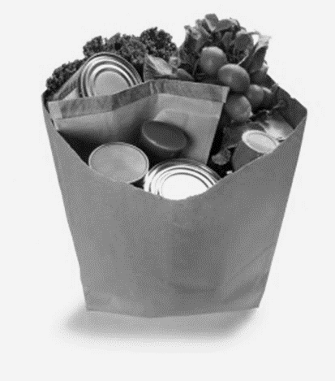
COVID-19 FOOD ASSISTANCE
FOOD PANTRIES
Aitkin Area Food Shelf | WEDS: 10:30 AM-3 PM | Curb-side pick- up and please wait for service for pre-packaged box. | 612-803-1839
Aitkin First Lutheran Food Shelf | 2nd & 4th THURS  9:30 AM-5 PM | Take out, drive through.  Emergency food boxes available during normal business hours, M-TH 8 AM-4 PM and Fri 8 AM-12 PM. | 218-927-2028
Aitkin St. James Catholic Church Food Self | TUES: 12PM – 3PM | 2 people in at a time. Food packaged for them. Considering pre-packaged take-out. Emergency Food Boxes: pick up outside of the office. | 218-927-6581  Ask for Aggie.
Garrison Food Shelf |  | Take out boxes only. Vehicle pick up. | 320-692-5399
Hill City Food Shelf | 3rd Sat of Month  8:30-11:30 AM | If you need assistance, call Bonnie and leave a message. Assistance will be provided based on availability. | 218-697-8263
Isle Food Shelf |  |  | 320-676-3795 (Karen)
Jacobson Food Shelf | 1st & 3rd Thursday of each month.  4:00-6:00 PM | 1 person in at a time. Also have pre-packaged boxes for take-out. | 218-426-4799 (Marcella)
McGregor Lord’s House Church Grocery Giveaway | Last FRI of Month  5-5:30 PM | Last Friday of the Month  HWY 210/65 next to Subway | 218-768-4795
McGregor Food Shelf | 2nd & 4th WED  9-12 PM | Will help anyone in McGregor with food on individual basis. | 218-426-3330 (Sharon)
Onamia Food Shelf | Mon & Wed 12-5 PM |  | 320-532-7665
Palisade Bethel Lutheran | MON & THURS 12-12:30 | Take out only. | 218-845-2429

REGULAR FOOD DELIVERY SERVICES
AEOA Senior Nutrition Services | No Change | Delivered to doorstep.
Meals on Wheels |  | Delivering to doorstep.
Palisade Loaves & Fishes |  | Delivering lunches
Ukura Big Dollar |  |  | 218-768-2666

COMMUNITY MEALS
First Lutheran Church Community Meal | Mon & Thurs | 5-5:30 PM | Round Robin through parking lot. | 218-927-2028
Aitkin First Lutheran Church Senior Tuesdays |  | 12-12:30 PM | Take out, drive through. | 218-927-2028
Disclaimer: The information provided above is current but may change on a daily basis.

